September 2022 Newsletter

Dear Parents

Welcome to the first Newsletter of this academic year and a warm welcome to all of our new families who are joining us and all who are already part of our OLSJ family. We are looking forward to continuing to build strong relationships that focus on making the very best provision for the children within our care.
We usually try to send letters out via ScoPay and all correspondence can be viewed on our school website. This year we have 91.8% of parents signed up for ScoPay. Please do make sure if your details change that you amend your account accordingly.

This is an exciting year ahead. I am trying to organise a raft of exciting trips for our children over the coming year. This will range from an exciting residential surfing and adventure trip to Cornwall for our intrepid Yea r6’s, through to a theatre trip to London for our younger junior children and maybe even an adventure to The Tower of London! KS1 children will explore more local castles, maybe visit the zoo and visits farms. News to follow on these once I have coordinated with venues. All very exciting. Thank you again for trusting us to make a difference to your children. We are aiming for adventure, nurture and academic excellence as we move through this year. If you know of any other families who may benefit from our passion for education, please do let them know our contact details.
THE PASSING OF HM QUEEN ELIZABETH II
The children in our school have been writing letters to His Majesty King Charles III to share with him our sympathy and condolences on the passing of his mother, wishing him well for his reign as our country’s new monarch, and outlining their hopes for the future as they grow up in the new Carolean Era. These are currently on display at Our Lady of Mercy and St Joseph Catholic Church, and formed part of the requiem Mass for the Queen.

We also reminded the children of the book and mug they received to mark the occasion of the Platinum Jubilee earlier this year and amongst other commemorations we watched the Paddington Bear ‘Marmalade Sandwich’ video, to show the Queen’s remarkable sense of humour and fun.

The Funeral of Queen Elizabeth II
A big thank you to Scott, Zoe and Mason who represented the school at a special requiem Mass for HRH Elizabeth II at OLMSJ Church on Monday 19 September.

The Mass was attended by the Deputy Lord Lieutenant for the New Forest - and was given a warm welcome by Zoe, who greeted her with a posy. The Deputy Lord Lieutenant was then shown to her seat at the front of the church, by Scott. Mason then made the school very proud, beautifully reading the responsorial psalm at the front of the church, to the whole congregation.
A very big thank you to all three pupils, who gave their own time to mark the passing of the Queen in such a special way.

Elizabeth II's Commemorative Tree
A very special thank you to the Catholic Women's League who bought the school a beautiful willow tree. They previously donated us a beautiful tree for our orchard, as part of our Jubilee Celebrations for 'The Queen's Green Canopy'. Our new willow tree arrived at the school just as Queen Elizabeth II passed away and therefore we thought it apt to add another tree to Her Majesty's Canopy and to name this tree for her.
Each class had a purple ribbon to tie onto the willow, with each child's name written upon it, to pay their respects to the Queen. We tied these ribbons to the willow tree at our ceremonial planting this morning. Each year group then read a special prayer that they had written in the Queen's honour. Many thanks to the Catholic Women's League for such a special gift, which we will treasure.

Queen Elizabeth's Jubilee Tapestry
Here is our beautiful tapestry in all its glory, created by the children during the Queen's Platinum Jubilee Celebrations. Each child in the school sewed their own square, creating a beautiful memento of the academic year 2021-22. Fr David blessed the tapestry during our Welcome Back Mass. We would like to dedicate our tapestry to the memory of Queen Elizabeth II, in the hope that it will prompt fond memories of her Majesty and our Jubilee celebrations. A big thank you to Miss Walker and her seamstress sisters, who spent a very long time putting the tapestry together!
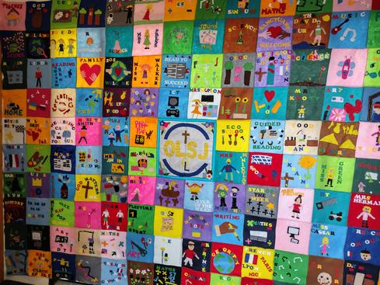

Art Skills Week
The children at Our Lady & St Joseph Catholic Primary School have an upcoming Art Skills week towards the end of this half term, each year group will be exploring and developing essential art and DT skills that will support them with their learning throughout the year. This is a brilliant opportunity for children to be creative and demonstrate any skills that they have already learned and are going to be able to apply across a variety of different outcomes. The skills they will be enhancing will support future units from designing photo-frames to moulding clay, this week is sure to be one the children will enjoy and remember throughout their primary school experience.
Curriculum and Enrichment
Year R
During our first weeks in Year R, we have learnt to explore our space. We have worked on establishing rules within our base to keep us ready, respectful and safe. Since our transition weeks, we have started focusing on a number a week as well as learning our first sounds in phonics! We are beginning to apply these to our writing!

Year 1
Have had a great start to the year! At the start of term, we received a letter in a bottle! It was from a pirate stating he needed our help in entering a pirate description competition! We have been using adjectives to write lots of exciting things about our own pirates and can't wait to read each other's fantastic pirate descriptions.

In Maths, we have been exploring what is more or less of a given number. We were introduced to our greedy crocodile and discovered how he always eats the biggest number! We have turned our crocodiles into symbols in our work and have even been able to create our own pictorial challenges!

In RE we have been learning about the creation story. We have been able to realise the impact humans have had on the world and what we can do to make the world happier again.

Year 2
We have been working super hard in Maths learning how to partition numbers into different combinations and number sentences. In Writing, we have created our own superheroes to save the day at OLSJ! We have included fantastic adjectives to describe them and explained what makes them such incredible heroes! In Science, we have been conducting lots of different experiments and practising our investigation skills, and in Geography we have travelled to all the capital cities in the UK – why not ask us about them?

Year 3
…have well and truly settled into Key Stage 2 and have had such a wonderful start! In particular, the children have enjoyed exploring rocks in Science. Here, the children have learnt about the formation of sedimentary, metamorphic and igneous rocks through a chocolate rock cycle demonstration; they enjoyed being able to see how rocks can transform just as chocolate does once heated and cooled!

In addition to this, the children have loved diving deeper into David Walliams' World's Worst Children book in both their Literacy and Guided Reading sessions. In Guided Reading, the children have thought about how to perform snippets of the text using key fluency skills in order to entertain their audience. In our writing lessons, the children have seen how this performative aspect affects how a text is written, and have begun planning their own world's worst child with these writing techniques in mind. We can't wait for you to read them to see if you agree that they've described the world's worst child!

Year 4
In Year 4 we have had a great start to the year! Our English topic for Autumn 1 is all about Miss Trunchbull. The children are currently writing character descriptions about this formidable character! We cannot wait to see Miss Trunchbull portrayed in real life at the theatre in December – it will be fantastic to see Matilda the Musical in Covent Garden!
In our afternoon learning, we have been learning about the Stone Age, Bronze Age and Iron Age. We have looked at different sources to learn about life in these times and how life changed from period one to another. It is fascinating to see the progression between the time periods! In Science we are learning about teeth and tooth decay. We will be doing different experiments to look at how teeth decay and what causes this. We will also look at the digestive system in more detail as part of our learning in this subject.

Year 5
In English, Year 5 have been creating a short story with a focus of creating fear and tension. They have learnt different figurative language techniques and carefully selected verbs and adverbs.

This term in maths the children have studied place value and looked at how large numbers can be broken down into their specific values. They have also tackled Roman numerals and practised number sequences and adding and subtracting with these numbers.

Year 6
We have been studying WW2 in our History work. We were lucky enough to receive a suitcase full of WW2 artefacts from Hampshire County Council and have been using our inference skills to decipher what they are and what they were used for. We have also researched how these objects have influenced and impacted today's world! We will be looking at Dunkirk in the coming weeks, and Operation Dynamo. Year 6 have also enjoyed swimming lessons this half term and a trip to Priestlands Secondary School to see the facilities they have on offer. The children very much liked the science lab and using the Bunsen burners!

Eco Leaders & School Council
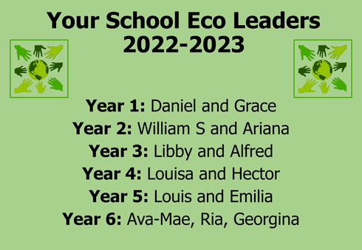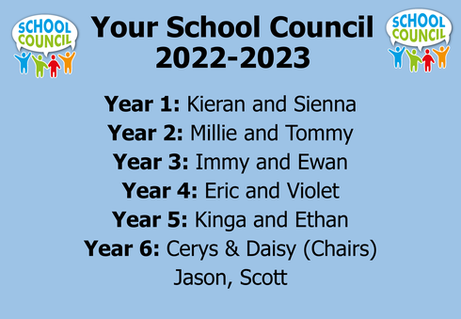

House Captains
St. Matthew:
House Captain: Ava
Sports Captain: Frankie
St. Mark:
House Captain: Emma
Sports Captain: Jason
St. Luke:
House Captain: Zoe
Sports Captain: Scott
St. John:
House Captain: Mason
Sports Captain: Tristan

Mission Statement Heroes
Our first "Mission Statement Heroes" were unveiled last week- those who have shown God in their Hearts, Love in their Words and Family in their Actions. We will celebrate our ‘Mission Statement Heroes’ alongside our Stars of the Week each Friday in Celebration Assembly.

Well done to:
Y1- Phoebe
Y2- Ollie
Y3- Evie
Y5- Elizabeth
Y6- Tristan

House Competitions

Knowledge
Times Tables – This half terms competition is focusing on our times table knowledge. We are very impressed with how excited the children are for this, and their super times table knowledge that we have seen so far.

Charity
Shoe Box Appeal
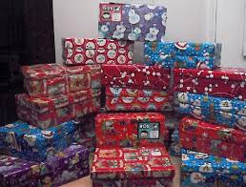
We are once again supporting The Rotary Club Shoebox Scheme for the children of Eastern Europe. If you would like to support this please send into school a shoebox filled with such items as: toys, clothing, games, books, pens, pencils etc… they need not be new as long as they are in good condition. Due to the increased difficulty in sourcing empty show boxes, the Rotary Club will be providing standard sized boxes which will be available from the school office for a donation of £2. Before filling your shoebox please cover the box and lid separately with festive paper and secure with a single elastic band. Please return boxes to school by Monday, 17th October.

Sport
Cross Country – the sports competition this half term will be cross country, which the children will complete in the PE lessons.
We will also be continuing to visit Priestlands Secondary School with small groups of students, for extra PE enrichment.

Farmer's Fare-Share
We donated some fresh produce that we have grown in our very own school gardens to the New Forest Basics Bank and FareShare earlier in the half term.
Pumpkins, thyme, apples and peppers that have been lovingly grown by OLSJ pupils have now been lovingly donated to those in need in our community. Well done to Mrs Rothwell who coordinated the growing and to Year 3 and Miss M who dug up our produce!
We have also been featured in this week's Lymington Times for our Eco successes- you can read the article below Please follow this link to the Lymington Times article
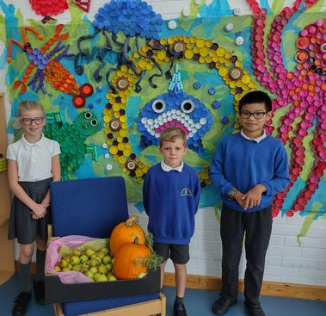
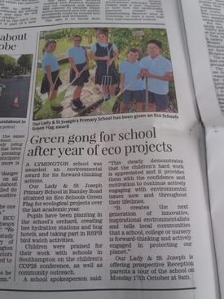

Year R Phonics

It was wonderful to welcome our new parents in to work with their children on the first of our Pip and Pap Phonics parent workshops! The children worked with their parents to teach them their new sounds - /s/ /a/ /t/ /p/ /i/ /n/ /m/ /d/ ! Then we blended words containing these sounds, using the story "Pip and Pap." The children and parents also created wonderful traffic lights using card, glitter and paints - something that the aliens had a little trouble with in the story. They looked fantastic!

We know that many of our parents are busy working during the school day and not always available to come in for workshops. However, if you wish to send along another adult to work with your child, such as a grandparent, you are more than welcome to do so! Younger siblings are also welcome - the more the merrier, though they must be supervised! Please ask Miss Cassar for more details.

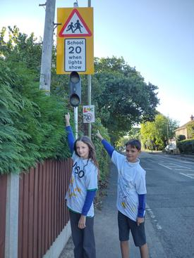
20's Plenty!
Have you noticed the new advisory 20mph speed limit signs outside the school? In both directions on Ramley Road? A big well done to our Junior Road Safety Officer Team who contacted Councillor Humby at Hampshire County Council. He agreed to put signs in place to alert traffic that there is a school nearby. However, we are still working towards a pedestrian crossing. Councillor Humby is visiting our school with Councillor Chadd on 3rd October, where our children will present an assembly, outlining the issues we are facing. Both councillors are happy to speak to parents - if you would like to express your opinion and help our cause, please let Mrs Reilly in the office know – we would very much appreciate your help.

After School Clubs
It has been fantastic to welcome back our afterschool clubs. Clubs will be running throughout the academic year on a termly basis. Please can I remind all parents that after school clubs finish at 4:15pm promptly, with the exception of the GIFT Team, that finishes at 4.30 on a Thursday. Thank you.

Senior School
Our main feeder school, Priestlands, have an open evening for parents on Tuesday, 4th October at 6.45pm and an Open Morning for parents on Friday 7th October.

Other Open Days:
St Anne's Catholic School (for girls) have an Open Morning for Y4,5,6 pupils on September 28th.
St George's Catholic College (boys and girls) have an Open Morning for parents on Thursday 6 October.
Arnewood School in New Milton have an open day on Wednesday 5th October.
Highcliffe School are also offering parent tours during October.

Please note that the Hampshire deadline for application for Secondary Schools is 31st October. Please visit this website to apply:
https://www.hants.gov.uk/educationandlearning/admissions/applicationprocess/year7

Allergies

We have a number of children and staff with severe nut allergies. With this in mind, we do
not have any nuts or nut products at snack time or in packed lunches. These include peanut
butter, Nutella or Pesto (which contains pine nuts). These can be a major cause of
anaphylactic shock in some adults and children. Your care and support in this is greatly
appreciated.

Uniform
A big thank you to all parents who have sent their children in the correct uniform. Our children are looking very smart. Uniform is an important part of our culture and our children certainly look very proud to be part of the OLSJ family.
We politely ask parents not to send their children to school wearing unsuitable shoes, eg trainers or boots – warm/welly boots can be worn at playtimes but sensible shoes inside please. School is very well heated, making boot wearing indoors, all day inappropriate. We also please ask that the children bring in their bookbags each day and not backpacks as the corridors become congested when they end up on the floor. Please also ensure the current PE kit is available - clothes/sportswear with slogans, popstars or football club logos are not for school. Thank you.
Start and end of the day
At the start of the day children can enter the building from 8.25am for an 8.30am start to our day.
In order to ensure the safe handover of children at the end of the day, please put in writing any alternative adult you give permission to, to collect your child/children and give to the school office. Teachers will be teaching and may not remember slips of paper and new instructions. If your child is in Year 5 or Year 6 and you wish for them to walk home unaccompanied, we need a written permission slip from a parent.
School meals
We encourage all of our children to have a hot school dinner, whether they are infants or juniors.
We have worked very closely with the school council, children and our caterers to ensure that the food offered is home cooked and delicious. We regularly chop meals off the menu and add new tastier options. All of our teachers eat a school dinner. We have a third `Jacket potato with filling’ option for those who do not like our meat or vegetarian option. I can assure you that our cooks are wonderful and I look forward to a school dinner every day! Please do consider this as a filling option to support your child’s learning in the afternoon. The menu is available on our website at www.OLSJschool.co.uk
If your child is going to arrive late to school and they wish to have a cooked meal at lunchtime, we would be grateful if you could let the office know in advance by telephone. Unfortunately, if your child arrives after 9.30am, and we have not been notified, your child will receive a “spare” meal. Always best to be on time, or phone ahead. Thank you.
Safety Reminder!
A gentle reminder, please can you ensure your child/ren do not play on the play equipment (play trails/trail area) before or after school. They are not suitable for use without school supervision. We also ask that children or adults do not ride bikes and scooters on the school playgrounds.
We again politely remind you that dogs are not permitted on the school site – this includes being held in arms. Thank you.
Day Closures 22-23
Our teachers and support staff have disaggregated training and therefore school will be closed on Thursday, 20th and Friday, 21st October this term. In the summer term the school will be closed on Thursday, 25th and Friday, 26th May.
Dates for your Diary
- Friday, 30 September – Flu Jabs with School Immunization Team
- Monday, 3 October – Councillor Chadd and Councillor Humby visit
- Tuesday, 4 October – Blessing of the Animals at OLMSJ Church – all animals welcome, great or small!
- Thursday, 6 October – National Poetry Day – we will be celebrating in school
- Monday, 10 October – CAFOD workshops in school
- Friday, 14 October – Harvest Sing Song at 8.45 am – parents welcome
- Monday, 17 October – Tour for prospective Year R pupils at 9am.
- Wednesday, 19th October - School Photographer
- Thursday, 20th October – Staff Inset Day– Disaggregated
- Friday, 21st October – Staff Inset Day– Disaggregated
- 24th to 28th October – Half Term
- Monday, 21st November- Robin Stevens Author Q&A – KS2 Book Club – Book via Tucasi
- Monday, 28th November – Jenny Pearson Author Q&A – KS2 Book Club – Book via Tucasi
- Thursday, 1st December – Y3/4 to see Matilda the Musical in London
- Thursday, 8th December – Y2 to see the Jolly Christmas Postman in Poole
- Thursday, 25th May – Staff Inset Day– Disaggregated
- Friday, 26th May – Staff Inset Day– Disaggregated
- w/c 26th June – Year 6 Residential to Bude

Best wishes

Gerida Montague
Executive Headteacher

